Correlation analysis result:

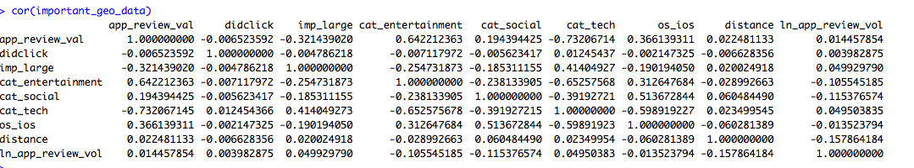 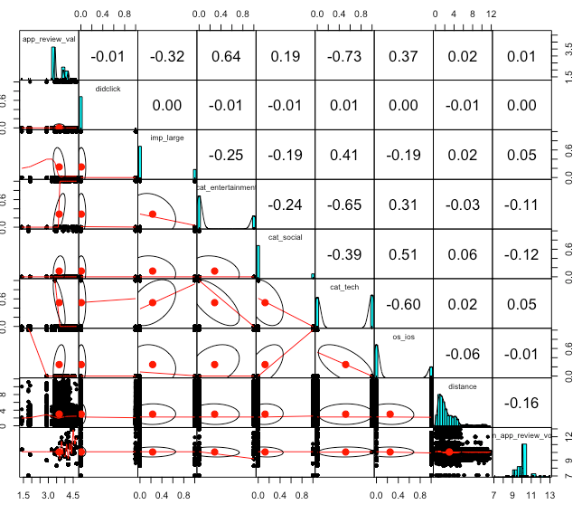

First of all, from the correlation analysis, we could see that did_click is positively correlated with variables like cat_tech, ln_app_review_vol and negatively related with variables like app_review_val, imp_large, cat_entertainment, cat_social, os_ios and distance. But is their relationship significantly? We could do logistic regression and check the P-Value.

Result of logistic regression:

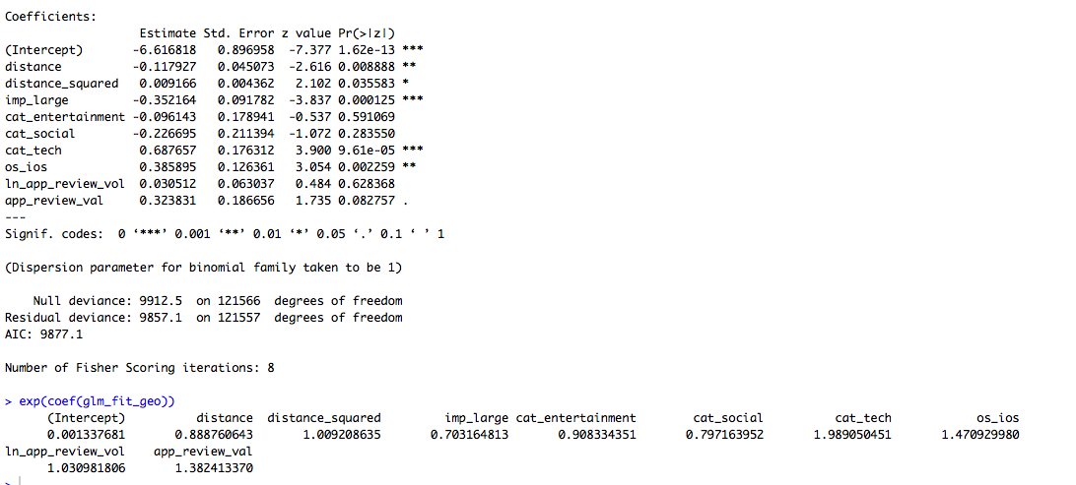

According to the logistic regression’s results, we could find that distance and imp_large are significantly negatively related to did_click. And cat_tech and os_ios have significant positive relationship with the dependent variable did_click.

Specifically, if it the value of large_imp is 1 which means imp_size="728x90", then it decreases the click by 30%. As for the distance variable, if it increases 1 kilometer, then the probability of click may decrease by 11.2 percent. Additionally, if the value of cat_tech is 1 which means the application is tech-related, then it could lead to 99% increase in click possibility. And if the operating system is IOS, then it could increase the click possibility by 47%.

Consequently, it may be better for business who want to use mobile ads to put more ads on users who use IOS system and put more ads trough tech-related APPS. Additionally, they may don’t want to put large impressions since its performance is not good according to analysis. And they may put more ads with distance becoming smaller and smaller.